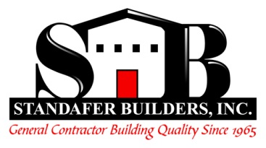

Standafer Builders, Inc. provides a Simple IRA for their eligible employees. The company matches each employee contribution up to 3%.

To be eligible to sign up for the Simple IRA:
- Must have worked with Standafer Builders, Inc. for 1 year
- Must have grossed $5,000 last year
- Must be expected to gross $5,000 this year

If you meet the requirements and want to sign up, please contact the office by calling 606-743-4435 or emailing standbu@mrtc.com between 8:00am and 4:30pm, Monday through Friday.

